Practical Software and Systems Measurement Continuous Iterative Development
Measurement Framework
Part 2: Measurement Specifications: Burndown

Version 2.1
April 15, 2021

Developed and Published by Members of:

Practical Software & Systems Measurement | National Defense Industrial Association | International Council on Systems Engineering
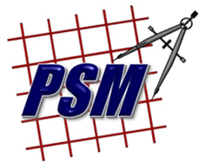
Product No.  PSM-2021-03-001 |  | Product No.  INCOSE-TP-2020-001-06

Editors:
Cheryl L. Jones  US Army  cheryl.l.jones128.civ@mail.mil |  | Geoff Draper  L3Harris Technologies  geoff.draper@l3harris.com
Bill Golaz  Lockheed Martin  willliam.h.golaz@lmco.com |  | Paul Janusz  US Army  paul.e.janusz.civ@mail.mil

Unclassified: Distribution Statement A: Approved for Public Release; Distribution is Unlimited

PSM Product Number: PSM-2020-06-001
INCOSE Product Number: INCOSE-TP-2020-001-06

Copyright Notice:
For this document, each of the collaborative organizations listed on the cover page is the sole manager of their products and services and are the only parties authorized to modify them. Since this is a collaborative product, modifications are managed through the participation of all parties.

General Use: Permission to reproduce, use this document or parts thereof, and to prepare derivative works from this document is granted, with attribution to PSM, NDIA, and INCOSE, and the original author(s), provided this copyright notice is included with all reproductions and derivative works.

Supplemental Materials: Additional materials may be added for tailoring or supplemental purposes if the material developed separately is clearly indicated. A courtesy copy of additional materials shall be forwarded to PSM (psm@psmsc.com, attention: Cheryl Jones). The supplemental materials will remain the property of the author(s) and will not be distributed, but will be coordinated with the other collaboration parties.

Author Use: Authors have full rights to use their contributions with credit to the technical source.

Supplemental Notice from INCOSE: This work is an Affiliate Product per INCOSE Policy TEC-107 INCOSE Technical Product Development & Commercialization (26 October 2018). It is a technical product developed outside the INCOSE product development process and was made by INCOSE members in cooperation with PSM and NDIA; then approved by INCOSE to be distributed from INCOSE central channels. The authors own the copyright and take primary responsibility for proper branding, intellectual property, content quality and appropriate citations with INCOSE oversight based on this policy & related procedure.

Contents
8. Measurement Specifications 1
8.2 Burndown (Team, Product, or Enterprise Measure) 1

List of Figures
Figure 1: Release Burndown 2

Measurement Specifications

Burndown (Team, Product, or Enterprise Measure)
Measure Introduction
Description | Burndown is used to monitor completed work items (e.g., stories, features, capabilities) vs. planned work items for an iteration, release, or capability. Work items may include design, code, test and all supporting activities (e.g., requirements development, configuration management and quality engineering). Progress toward completing planned work is depicted graphically to provide an indicator of the likelihood of meeting planned goals.
Relevant Terminology | See Section 3 in Part 1: Ontology and Definitions.

Information Need and Measure Description
Information Need | What is the status of the iteration, release, or capability? Will all the remaining committed work be completed as planned? What are the features/capabilities at risk of not being completed as scheduled? What are the trends in execution relative to plan?
Base Measure 1 | Planned Work (integer scale)  (e.g., Story Points/Features/Capabilities)
Base Measure 2 | Completed Work (integer scale)  (e.g., Story Points/Features/Capabilities)
Derived Measure 1 | Open Work = Planned Work - Completed Work  (e.g., Story Points/Features/Capabilities)

Indicator Specification
Indicator Description and Sample | In Figure 1, the teal line represents the number of open stories over time, while the dark blue line indicates the planned burndown. This chart shows a 2-month release, with weekly increments, where stories are completed.  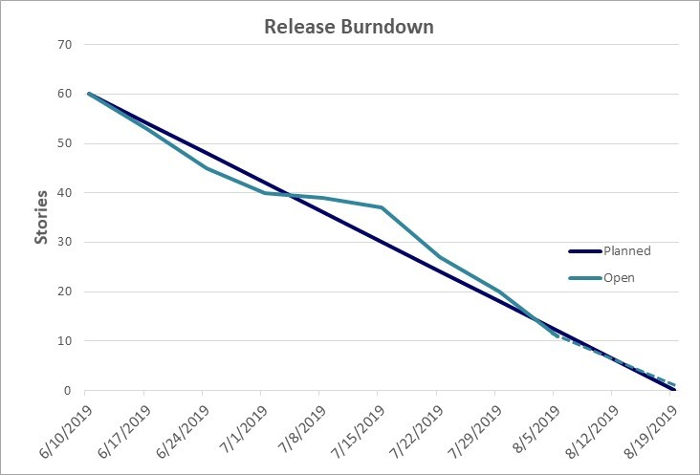  Figure 1: Release Burndown  At release planning, work items representing 60 stories were committed. While little progress was made during the first week to a planned training event, the teams recovered and is projected to complete the planned work by the end of the release.
Analysis  Model | At the team level, the focus is generally on stories or story points open through the iteration. Is the team completing the committed work items? Are they significantly behind or ahead of the burndown plan? Are items blocked? What is the likelihood of meeting the commitment on time? Can additional backlog stories be brought into the iteration? Are teams improving execution over time?  At the product level, the focus turns to features or capabilities across releases. At the enterprise level, the focus is generally on capabilities for external releases.
Decision Criteria | At the team level, lack of progress (e.g., not reducing open story points at all over several days) and variances from the plan (e.g., 5%) should be reviewed for action by the team. Data is generally not shared externally to the team.  At the product level, variances of over 10% are reviewed for causes of roadblocks and consideration of replanning.

Additional Information
Additional Analysis Guidance | Use this metric with the velocity metric and other work unit progress metrics (e.g., test progress, cumulative flow). The velocity metric supports the planned story points for each iteration. The actual completed story points from the iteration is an input to the velocity metric. Review with other work unit progress metrics may support an assessment of overall risk and may impact prioritization of work for future iterations.  Consider bounds of estimated burndown based on historical performance, e.g., best case, worst case, Monte Carlo analysis.
Implementation Considerations | Estimates are typically based on measures of relative effort, such as user stories, story points, or other validated alternatives based on clear, repeatable operational definitions.

Additional Specification Information
Information Category | Schedule and Progress
Measurable Concept | Work Unit Progress
Relevant Entities | Product
Attributes | Story Points, Features, Capabilities
Data Collection Procedure | At the team level, story points committed for each iteration are determined at the iteration planning meeting. This value is determined from the velocity metric. Based on the average velocity and other factors (e.g., vacations), the team commits to a number of story points for the next iteration. Work items (e.g., stories, tasks) are selected to match this commitment. Work items are closed when completed and meet their evaluation criteria, and burndown progress is updated daily.  At the product level, the features and capabilities committed for each release are determined during release planning. Commitments may be replanned as work is completed and priorities change.
Data Analysis Procedure | For the team, Burndown is analyzed daily for progress/risk and at the end of each iteration to determine if the story points were delivered as committed. The final story points completed value is an input to the velocity metric.  For the project, Burndown is analyzed periodically (e.g., monthly, quarterly, by release). For the enterprise, Burndown of capabilities for major events is analyzed.

