Practical Software and Systems Measurement Continuous Iterative Development
Measurement Framework
Part 2: Measurement Specifications: Committed vs Completed

Version 2.1
April 15, 2021

Developed and Published by Members of:

Practical Software & Systems Measurement | National Defense Industrial Association | International Council on Systems Engineering
Product No.  PSM-2021-03-001 |  | Product No.  INCOSE-TP-2020-001-06

Editors:
Cheryl L. Jones  US Army  cheryl.l.jones128.civ@mail.mil |  | Geoff Draper  L3Harris Technologies  geoff.draper@l3harris.com
Bill Golaz  Lockheed Martin  willliam.h.golaz@lmco.com |  | Paul Janusz  US Army  paul.e.janusz.civ@mail.mil

Unclassified: Distribution Statement A: Approved for Public Release; Distribution is Unlimited

PSM Product Number: PSM-2020-06-001
INCOSE Product Number: INCOSE-TP-2020-001-06

Copyright Notice:
For this document, each of the collaborative organizations listed on the cover page is the sole manager of their products and services and are the only parties authorized to modify them. Since this is a collaborative product, modifications are managed through the participation of all parties.

General Use: Permission to reproduce, use this document or parts thereof, and to prepare derivative works from this document is granted, with attribution to PSM, NDIA, and INCOSE, and the original author(s), provided this copyright notice is included with all reproductions and derivative works.

Supplemental Materials: Additional materials may be added for tailoring or supplemental purposes if the material developed separately is clearly indicated. A courtesy copy of additional materials shall be forwarded to PSM (psm@psmsc.com, attention: Cheryl Jones). The supplemental materials will remain the property of the author(s) and will not be distributed, but will be coordinated with the other collaboration parties.

Author Use: Authors have full rights to use their contributions with credit to the technical source.

Supplemental Notice from INCOSE: This work is an Affiliate Product per INCOSE Policy TEC-107 INCOSE Technical Product Development & Commercialization (26 October 2018). It is a technical product developed outside the INCOSE product development process and was made by INCOSE members in cooperation with PSM and NDIA; then approved by INCOSE to be distributed from INCOSE central channels. The authors own the copyright and take primary responsibility for proper branding, intellectual property, content quality and appropriate citations with INCOSE oversight based on this policy & related procedure.

Contents
8. Measurement Specifications 1
8.3 Committed vs Completed (Team, Product, or Enterprise Measure) 1

List of Figures
Figure 1: Stories Completed versus Committed 2
Figure 2: Program Completed versus Committed 3

Measurement Specifications

Committed vs Completed (Team, Product, or Enterprise Measure)
Measure Introduction
Description | Committed vs Completed is a measure of progress toward completing planned, or expected, features and capabilities. At the team level it may be used to measure progress of each iteration. At the program or organizational level, it can be used to measure overall progress toward a release and completing product development. It may also be used to measure quality of the product by indicating product readiness with respect to expected capability, or functionality.
Relevant Terminology | Stories Committed Stories the team has committed to complete within an iteration.  Features, or Capabilities, or Committed Features and capabilities committed to the customer by the program to be included in the product.  Completed Stories, Features, or Capabilities Stories that have completed their level of verification and validation and have been proven to work as expected.

Information Need and Measure Description
Information Need | Are Stories, Features, or Capabilities delivered as committed? What are the Stories/Features/Capabilities at risk of not being completed as scheduled?
Base Measure 1 | Work Items Committed Each Iteration (integer)  (e.g., stories, story points)
Base Measure 2 | Work Items Completed Each Iteration (integer)  (e.g., stories, story points)
Base Measure 5 | Work Items Committed Each Release (integer)  (e.g., features, capabilities)
Base Measure 6 | Work Items Completed Each Release (integer)  (e.g., features, capabilities)
Derived Measure 1 | Percent Work Items Completed = (Sum of All Work Items Completed) * 100 / (Sum of All Work Items Committed) for a desired iteration, release, or program  (e.g., stories, story points, features, capabilities)

Indicator Specification
Indicator Description and Sample | In Figure 1, Stories Committed is graphed as a column for each iteration [dark blue bar] and stories Completed as a column for each iteration [green bar]. Cumulative Percent Stories Completed are also graphed as a line chart across iterations (secondary axis). The indicator may be aggregated for a release, set of features, capability, or a complete project to provide progress toward product completion.  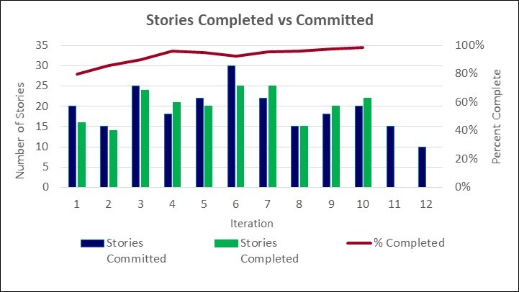  Figure 1: Stories Completed versus Committed  Iterations 1, 2, 3, 5 and 6 did not complete expected stories. During iterations 1 and 2, the team was forming and learning to work together. Iteration 3 completed close to expected stories. Iterations 4, 7, and 9 completed above expected stories. The team was working together and attempting to catch up on the backlog of stories. This could also reflect rework that was being identified and resolved. Current percent complete does not indicate a need for a re-plan but progress and velocity should be watched to ensure the team can complete the remaining backlog over the next two minor iterations.
Figure 2 shows a product level view of completion, for Features Committed. Monthly data is graphed, along with a cumulative percentage complete.
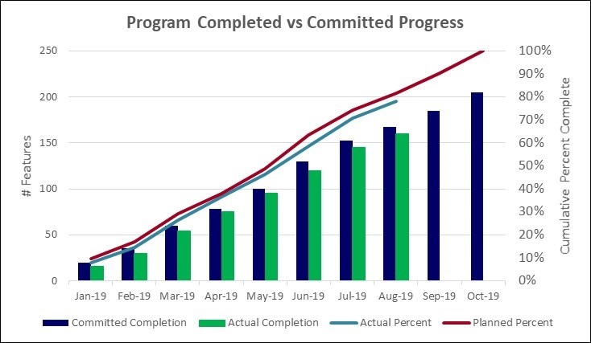
Figure 2: Program Completed versus Committed
The month-to-month cumulative view of the same data shows the project is not completing committed features creating a backlog of work. The gap between planned percent complete and actual percent complete is increasing slightly and is behind target to complete all features by project end. Some corrective actions may be needed.
Analysis  Model | Is the team and project completing the assigned work? Will they deliver required features within allocated project schedule? Teams may not complete all Stories for each iteration, so this indicator provides information about any backlog of features growing as you progress through the release or program.
Decision Criteria | If the gap between committed and actual completion is more than 5%, than the team should investigate causes of lack of completions. If any team is more than 10% behind commitments, than the project management should investigate and consider corrective action.  If the product completion is more than 10% behind commitments, than alternative courses of action (e.g., adding additional teams or changing commitments) should be considered.

Additional Information
Additional Analysis Guidance | Use this with the Committed Backlog, Burndown, and Velocity to ensure project will release identified features (or capabilities) as scheduled. The project may want to use different levels of aggregation to view the progress at different levels to expose any adverse trends.  If a story is not completed within its expected iteration, it will be placed back on the backlog and re-prioritized for a future iteration. If a team completes assigned stories for an iteration with additional time to work, they should select additional stories from the backlog.  Stories, Features, or Capabilities may be weighted by complexity to give a more complete view of program completion.
Implementation Considerations | In general, Committed vs Completed Stories is specific to a team since story point size may vary from team to team.  An aggregate measure at the Feature or Capability level can be compiled across teams and compared to capability roadmap to see if project is completing multi-team capabilities within project expectations.

Additional Specification Information
Information Category | Schedule and Progress
Measurable Concept | Work Unit Progress
Relevant Entities | Stories, Features, or Capabilities
Attributes | Story Points (estimated size), Iteration Committed, Iteration Completed for each entity
Data Collection Procedure | For team measure, data is collected at the end of each iteration by the team lead from the team tracking tool. Story Points must be tested and satisfy “Done” criteria, with no open defects to be counted as completed. If a Story does not satisfy “Done” criteria, then it is not considered “Complete” and its Story Points are not included in the total of Completed Story Points.  For product or enterprise measures, data is collected periodically (e.g., monthly, quarterly, end of each iteration or release).
Data Analysis Procedure | Data is analyzed at the end of each iteration by the team during the iteration review and considered during the planning session for the follow-on iteration.  The data is also aggregated and analyzed at summary levels across iterations or releases to ensure the program is completing its committed capabilities.

