Nineteenth Practical Software and Systems Measurement (PSM)

USERS’ GROUP WORKSHOP

Registration Form

“Fundamental Measurement Principles: The Basis for

Advanced Engineering Decision Information”

Crystal City, Arlington, VA

10 - 14 September 2018

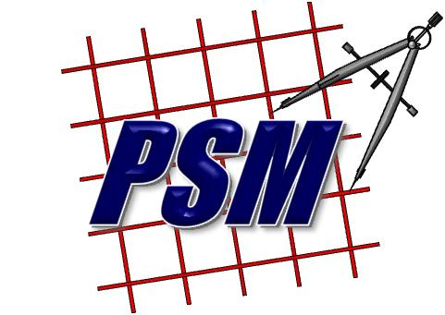 | PROGRAM AT A GLANCE
 | Monday, September 10 | Registration, PSM One-Day Training
 | Tuesday, September 11 | Welcome, Keynote, Presentations, Workshops
 | Wednesday, September 12 | Keynote, Presentations, Workshops, group Dinner
 | Thursday, September 13 | Presentations, Workshops
 | Friday, September 14 | Presentations, Workshop Outbriefs, Wrap-Up session (am only)

MEETING SITE:

Lockheed Martin Global Vision Center

2121 Crystal Drive

Arlington, VA 22202

You are responsible for making room reservations. There are many hotels near the meeting location, in Crystal City.

TRANSPORTATION:
National Airport (DCA) - 1 mile SW - free hotel shuttle, metro, or taxi
Dulles (IAD) - 28 miles W - Super Shuttle or taxi
BWI International Airport (BWI) - 37 miles NE - public transit, shuttle, or taxi
AMTRAK Train Station Union Station, D.C. (WAS) - 8 miles NE - metro or taxi

USER GROUP FEES:
$295 if registration form* is received by August 15, 2018
(your credit card will be charged on September 7, 2018)

$395 if registration form* is received after August 15, 2018

Complete and submit the attached registration form.

REGISTRATION:
The PSM Support Center will email participants a confirmation email after receiving a completed registration form.

REFUND POLICY:
Cancellations received by email or in writing to the PSM Support Center by September 5, 2018, will receive a refund. Substitutions or alternate persons are acceptable.

NINETEENTH ANNUAL PSM USERS’ GROUP MEETINGS and WORKSHOPS

Crystal City, VA
10-14 September 2018

REGISTRATION FORM

Payment Options: (Billing/Invoicing/DD1556 is not an acceptable form of payment.)
Users’ Group Fees:
$295 if payment is received by August 15, 2018
$395 if payment is received after August 15, 2018

( ) Check enclosed and payable to “IEI” (Independent Engineering, Inc.) Address on bottom of this form.
or: ( ) Credit card
MC Visa

Name on card:
Card #:
Expiration date: | 3 Digit Code: | Zip Code:

or: ( ) Use paypal option “Pay now” on the PSM web site, http://www.psmsc.com/Events.asp, under the Users’ Group
section (DO NOT USE THIS OPTION IF YOU ARE PAYING WITH A GOVERNMENT PURCHASE CARD)

Attendee Information:
Last Name/First Name/ MI:
Organization (if using an acronym, please define):

Name to appear on badge:
Mailing Address:
City/State/Zip:
Telephone/Fax
Email:
US Citizen: Yes No (if no, we will ask for some additional information)

Next page, please.
A training course will be held Monday, 10 September. If you plan to attend, please check the box below:
PSM One-Day Training Course (Recommended for individuals with little or no PSM experience.)

I will be attending Users’ Group events on:
Tuesday Wednesday Thursday Friday

Lunch will be provided for attendees, with registration. Please check the appropriate boxes below:
I will attend lunch on Monday
I will attend lunch on Tuesday
I will attend lunch on Wednesday
I will attend lunch on Thursday

The group dinner will be held on Wednesday, 12 September. Please check the appropriate boxes below:
Myself
Myself and ____ guest(s) (Guests are welcome to attend the group dinner on Wednesday evening for an additional fee. The cost of dinner has not yet been determined. However, we expect it to be approximately $40/per person. The cost of the dinner will be processed separately.)

*If you have any special dietary needs, please contact Dave Morris (contact information below).

Attire is business casual.
The agenda will be updated (as we accept presentations and workshops) and posted on the PSM web site, http://www.psmsc.com/Events.asp

Submit this form in one of two ways:

MAIL: PSM Administrative Services EMAIL: psmug2018@psmsc.com
PSM 2018 Users’ Group
47196 Middle Bluff Place
Potomac Falls, VA 20165
Phone: 703-405-2191

Sponsored by the PSM Support Center and the International Council on Systems Engineering
Web site: http://www.psmsc.com
